TI 22 - 22 Technology Example - Clearwell Scale inhibition technology using radio waves:

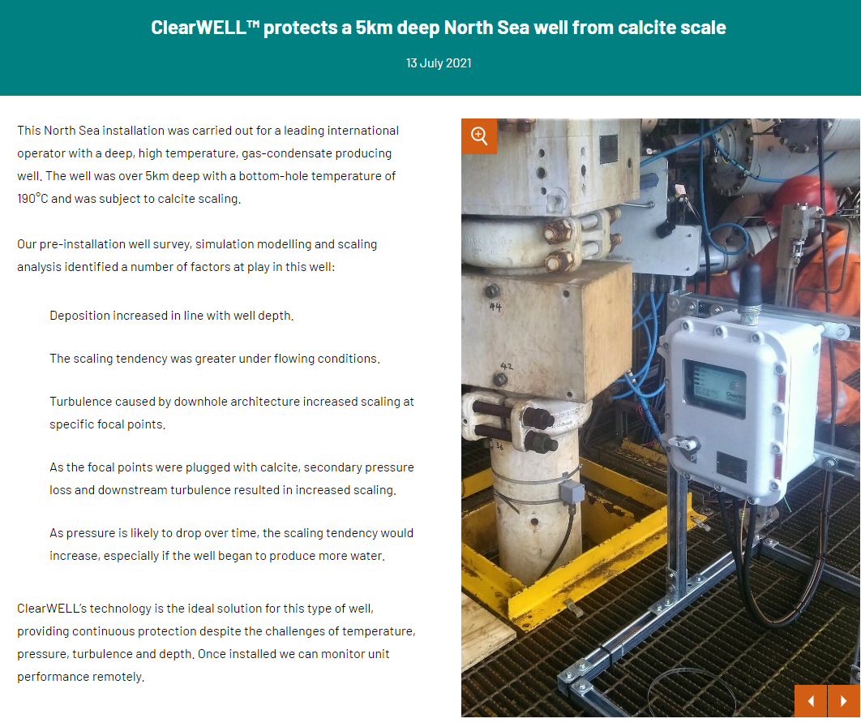

Link to Vendors website:
ClearWELL Energy - Worldwide Flow Assurance Solutions

